Day_2_MT_Password Cracking
Cybersecurity Training - Day 2 Notes
1. Introduction to Passwords
What is a Password?
An arbitrary long sequence of characters
Should be kept secret
Should be difficult to guess

The Authentication Problem
Fundamental Question: How do you prove to someone that you are who you claim to be?
Every access control system must solve this problem
Challenge: "On the Internet, nobody knows you're a dog"

Why We Need Passwords
Authentication: User has a secret password; system verifies it
Vulnerability: Passwords transmitted over networks are vulnerable to eavesdropping

2. Password Security Fundamentals
Key Security Questions
How easy is it to guess the password?
How is the password stored?
How does the system check the password?

Password Guess Difficulty
Basic Example: 3-Digit Lock
Only digits (0-9): 10 possibilities per digit
Total combinations:
10×10×10=1,000
Success probability: 1 in 1,000
Enhanced Example: 3-Character Lock
Digits + lowercase letters: 36 possibilities per character
Total combinations:
36×36×36=46,656
Success probability: 1 in 46,656

Real-World Passwords (8+ characters)
Typical password: 8+ characters with mixed character sets
With 36 possibilities per character:

Question: Is this enough security?

Brute Force Attack Complexity
Full character set: 26 letters + 10 digits + 10 punctuation = 46 possibilities
For 10-character password:

3. Modern Password Cracking Capabilities
Hardware Performance
Nvidia RTX 4090 Graphics Card: Extremely powerful for password cracking
Performance benchmarks:
NTLM authentication: 300 billion hashes per second (GH/s)
Bcrypt: 200,000 hashes per second (kH/s)

Password Cracking Time Estimates

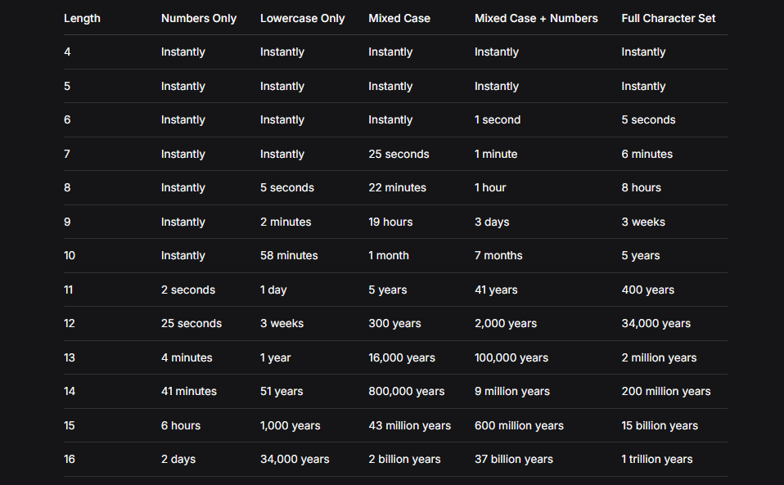

4. Human Password Behavior
Problem: Random vs. Actual Passwords
Random passwords would look like:
j39dh5ks
d93kdh3a
k30fj50d

But real passwords typically contain:
Personal information (names, birthdates, phone numbers)
Sports teams and terms
Cities and locations
Months, weekdays, seasons
Food items
Keyboard patterns (qwerty, 123456, etc.)

Common Weak Passwords (Top 20)
123456
Admin
12345678
123456789
1234
12345
Password

123
Aa123456
1234567890
UNKNOWN
1234567
123123
111111
Password
12345678910
000000
Aa123456

5. Dictionary Attacks
English Dictionary Statistics
Approximately 170,000 words in English dictionary
Common password patterns:

Attack Methodology
Adversaries collect passwords from previous database breaches
Reuse or combine these passwords to increase success rates
Modern GPUs can quickly test billions of password combinations

6. Multi-Factor Authentication (MFA)
Authentication Factors
Knowledge Factors (What you know)
Usernames/IDs
Passwords
PINs

Possession Factors (What you have)
One-time password tokens
Key fobs
Smartphone apps
ID cards

Inherence Factors (What you are)
Biometrics (retina scans, fingerprints, facial recognition)
Voice authentication

Two-Factor Authentication (2FA)
Standard Implementation:
Password (knowledge factor)
Mobile phone verification (possession factor via SMS/email)

Attack Requirements:
Compromise the password
Steal/access the user's mobile device

7. Cipher Modes of Operation
Purpose
Encrypt fixed blocks of plaintext using secret keys and initialization vectors
Provide both confidentiality and authenticity

Common Modes
Electronic Code Book (ECB) Mode

Each block encrypted independently
Identical plaintext blocks produce identical ciphertext blocks

Cipher Block Chaining (CBC) Mode
Each plaintext block XORed with previous ciphertext block
Provides better security than ECB

Authenticated Encryption Modes
Message Authentication Code (MAC) Approaches:
Encrypt-then-MAC (EtM): Encrypt first, then compute MAC
Encrypt-and-MAC (E&M): Encrypt and compute MAC separately
MAC-then-Encrypt (MtE): Compute MAC first, then encrypt both

Authenticated Encryption with Associated Data (AEAD):
Adds additional data to ciphertext
Thwarts chosen ciphertext attacks
Ensures both integrity and authenticity

8. Hash Functions
Definition
Mathematical function mapping arbitrary-size data to fixed-size output
Creates a "digital fingerprint" of the original data
Examples: MD5, RIPEMD-160, SHA-1, SHA-2, SHA-3

Key Properties
One-way function: Cannot reverse the process (no "de-hashing")
Deterministic: Same input always produces same output
Fixed output size: Regardless of input size
Avalanche effect: Small input changes cause large output changes

Applications
Standalone use:
File integrity verification
Password storage
Public key fingerprints

Combined with encryption:
Hash-based Message Authentication Code (HMAC)
Digital signatures
Blockchain technology

9. Hash Function Security Requirements
1. Preimage Resistance (One-Way)
Requirement: Given a hash output, cannot find any input that produces it
Formula: Given h, cannot find M such that H(M) = h
Purpose: Prevents recovery of original data from hash

2. Second Preimage Resistance (Weak Collision Resistance)
Requirement: Given input M, cannot find different input M' with same hash
Formula: Given M, cannot find M' ≠ M such that H(M) = H(M')
Purpose: Prevents substitution attacks

3. Collision Resistance (Strong Collision Resistance)
Requirement: Cannot find any two different inputs with same hash
Formula: Cannot find any M ≠ M' such that H(M) = H(M')
Note: Collision resistance implies second preimage resistance

10. Hash Function Algorithms
MD5 (Message Digest Algorithm 5)
Output: 128 bits
Status: Completely broken (collisions found in 2004)
Current use: Not recommended for security applications

SHA-1 (Secure Hash Algorithm 1)
Output: 160 bits
Status: Considered insecure for collision resistance
Note: One-way property still holds, but deprecated for most uses

SHA-2 Family
Variants: SHA-224, SHA-256, SHA-384, SHA-512
Output sizes: 224, 256, 384, 512 bits respectively
Status: SHA-256 is current standard for most applications
Usage: SSL certificates, cryptocurrency transactions
Security: No practical attacks known

SHA-3 Family
Variants: SHA3-224, SHA3-256, SHA3-384, SHA3-512
Innovation: Based on sponge construction
Advantages: Faster implementation, lower computational costs
Status: Ready to replace SHA-2 when needed

11. Secure Password Storage
Basic Approach: Store Hashes, Not Passwords
System stores hash of password, not password itself
During authentication: hash input password and compare with stored hash
Benefit: Even if database compromised, passwords not directly exposed

Salting: Defeating Precomputed Tables
Problem Without Salt
Identical passwords hash to identical values
Attackers can precompute hash tables (rainbow tables)
One table works for all password files with same hash function

Solution: Add Salt
Salt: Random value added to password before hashing
Effect: Attacker must recompute hashes for each salt value
Implementation: Store (salt + hash(salt + password)) in database

Key Stretching (Iterative Hashing)
Concept: Repeatedly hash the password many times
Purpose: Increase computational cost for attackers
Effect: Precompiled dictionary attacks become useless
Common algorithms: PBKDF2, bcrypt, scrypt, Argon2

12. Blockchain Technology
Basic Concept
Blockchain: Distributed ledger technology (DLT)
Function: Records and stores transaction history in linked blocks
Structure: Blocks cryptographically linked to form chain
Key feature: Immutable, transparent record-keeping

Cryptographic Foundations
Hash functions create digital fingerprints of blocks
Cryptographic linking ensures chain integrity
Consensus mechanisms validate new blocks

13. Password Security Best Practices
For Users:
Use long passwords (12+ characters minimum)
Mix character types: uppercase, lowercase, numbers, symbols
Avoid personal information and common words
Use passphrases instead of passwords
Never reuse passwords across different sites
Enable multi-factor authentication wherever possible
Use password managers to generate/store strong passwords

For System Administrators:
Store only password hashes, never plaintext
Always use salt with password hashing
Implement key stretching (bcrypt, PBKDF2, Argon2)
Enforce strong password policies
Implement rate limiting on login attempts
Monitor for unusual login patterns
Keep hash functions updated (use SHA-256 or SHA-3)

For Developers:
Never implement custom crypto - use established libraries
Follow OWASP guidelines for password handling
Implement proper session management

Use HTTPS everywhere
Regular security audits of authentication systems

14. Attack Mitigation Strategies
Against Brute Force Attacks:
Implement account lockout after failed attempts
Use CAPTCHA challenges after multiple failures
Increase hash iteration counts to slow down attacks
Monitor for rapid successive login attempts

Against Dictionary Attacks:
Enforce password complexity requirements
Check new passwords against known breached password lists
Implement password blacklists (common passwords)
Educate users about password strength

Against Credential Stuffing:
Detect and block automated login attempts
Implement device fingerprinting
Use multi-factor authentication
Monitor for credential reuse across accounts

15. Emerging Trends & Future Considerations
Passwordless Authentication
Biometric authentication (fingerprint, facial recognition)
Hardware security keys (FIDO2/WebAuthn)
Magic links via email
One-time codes via authenticator apps

Post-Quantum Cryptography
Developing hash functions resistant to quantum attacks
Preparing for quantum computing threats to current crypto

Behavioral Biometrics
Analyzing typing patterns
Mouse movement characteristics
Device usage patterns for continuous authentication

16. Review Questions
Conceptual:
Why are short passwords with limited character sets insecure?
What are the three main types of authentication factors?
How does salting improve password hash security?
What's the difference between preimage resistance and collision resistance?
Why is multi-factor authentication more secure than single-factor?

Practical:
Calculate the number of possible 8-character passwords using 72 possible characters
What makes bcrypt more secure than simple SHA-256 for password storage?
How would you detect a brute force attack in progress?
What information should never be included in passwords?
How does a dictionary attack differ from a brute force attack?

Analytical:
If a system uses 4-digit PINs, how many failed attempts should trigger a lockout?
Why might an attacker prefer GPU-based cracking over CPU-based?
How do rainbow tables work, and why are salts effective against them?
What are the trade-offs between password complexity and usability?
How could behavioral analysis help detect compromised accounts?

17. Summary of Key Points
Password Security:
Length and complexity dramatically increase cracking time
Human behavior often weakens password strength
Modern hardware can crack weak passwords quickly
Common passwords are extremely vulnerable

Hash Functions:
One-way transformation for data fingerprints
Security properties: preimage, second preimage, collision resistance
SHA-256 is current standard for most applications
MD5 and SHA-1 are deprecated for security uses

Secure Storage:
Never store plaintext passwords
Salting defeats precomputed hash tables
Key stretching increases attacker workload
Multi-factor authentication adds critical defense layers

Best Practices:
User education is essential for password hygiene
System design must incorporate security from start
Regular updates to cryptographic implementations
Defense in depth through multiple security layers

